**GONZAGA UNIVERSITY**

**School of Engineering and Applied Science**

**Center for Engineering Design and Entrepreneurship**

**Medcurity Network Inventory**

**Project System Design Plan**

**Section 03**

**Release:**

**Draft v0.1**

**PROJECT PLAN DRAFT STAGE DOCUMENT**

**September 24th, 2023**

**

**Brandon Huyck**

**Colleen Lemak**

**Artis Nateephaisan**

**Jack Nealon**

**3 Design Considerations**

**3.1 Initial User Interface Design**

Provide a description of the general user interface layout, including a set of initial user interface design mock-ups. Your text should provide a general description of how each mock-up will function. Each mock-up should be put into a separate figure (with a caption). Your mock-ups can be hand-drawn or digitally formatted, but must be clear and easy to follow. Your mock-ups must also be vetted with your project sponsor/liaison. Relate your interface designs to your project’s major features (e.g., state what features each mock-up will accommodate and how). State the process you used to arrive at the mock-ups, focusing on how the mock-ups have been vetted by your target users, your sponsor, and other project stakeholders, and the feedback you have received. 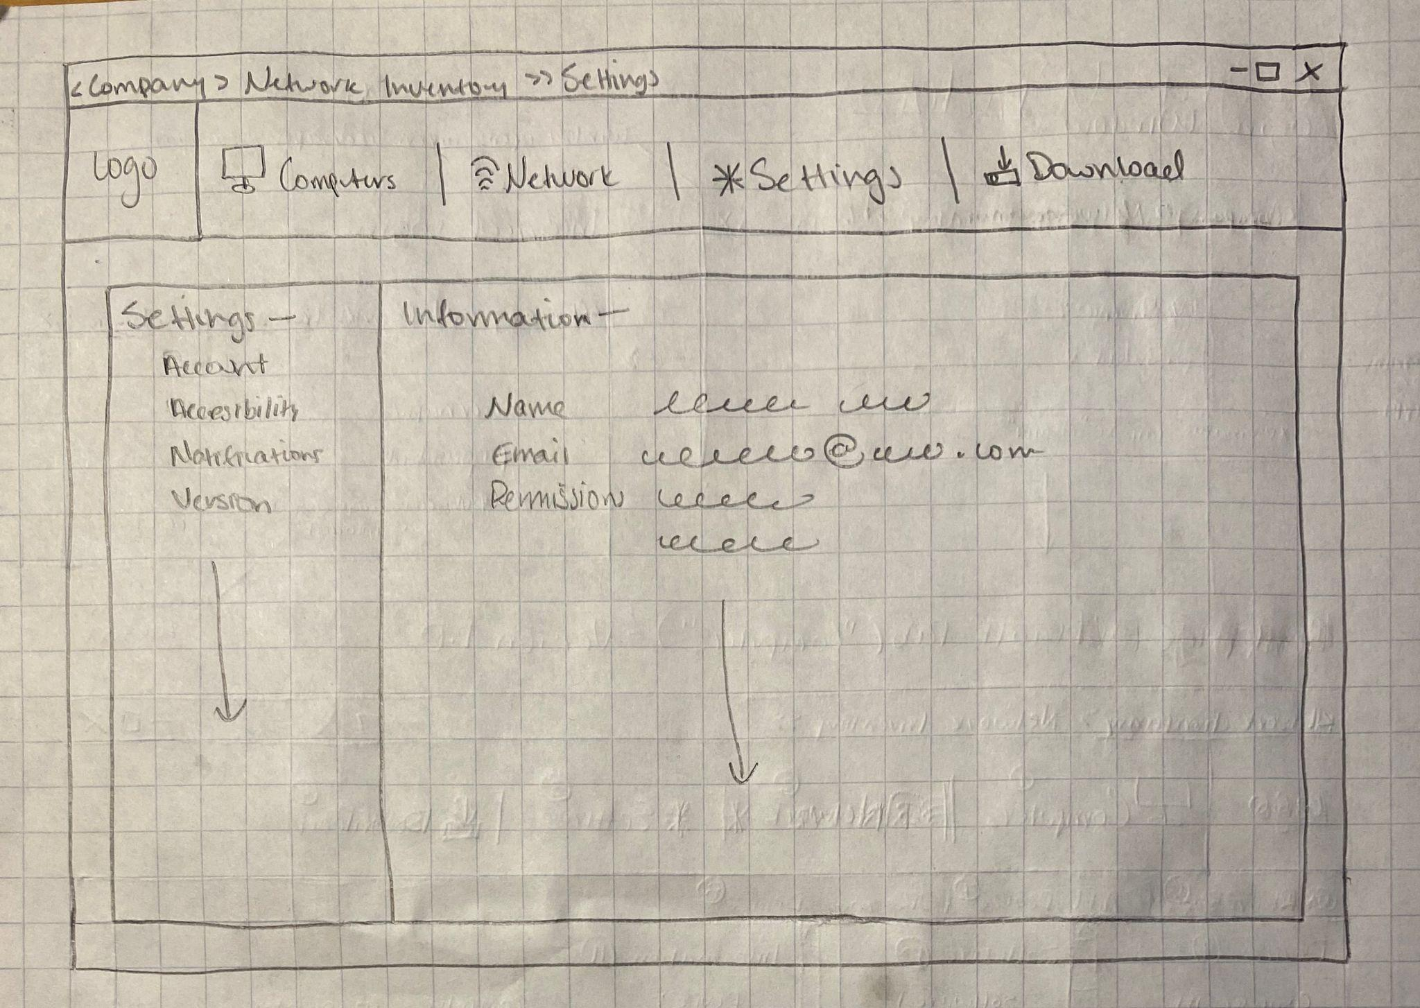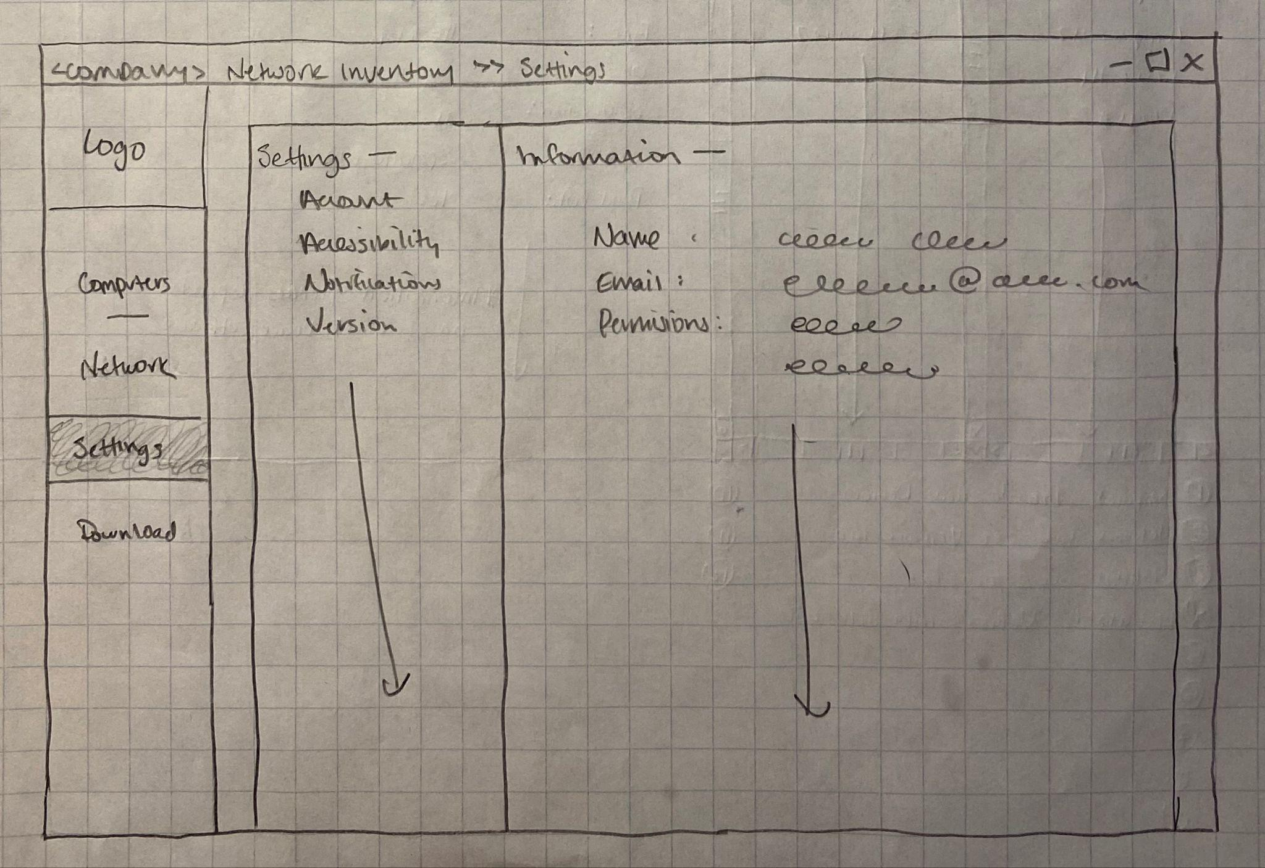

Version 1 Sketch and Storyboard —-

The login window will appear when the program starts up.

Login Window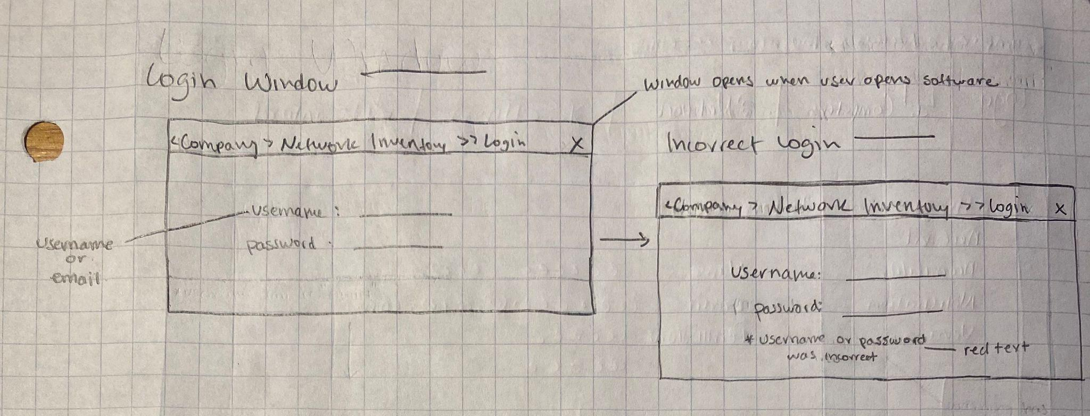

Homepage Version 1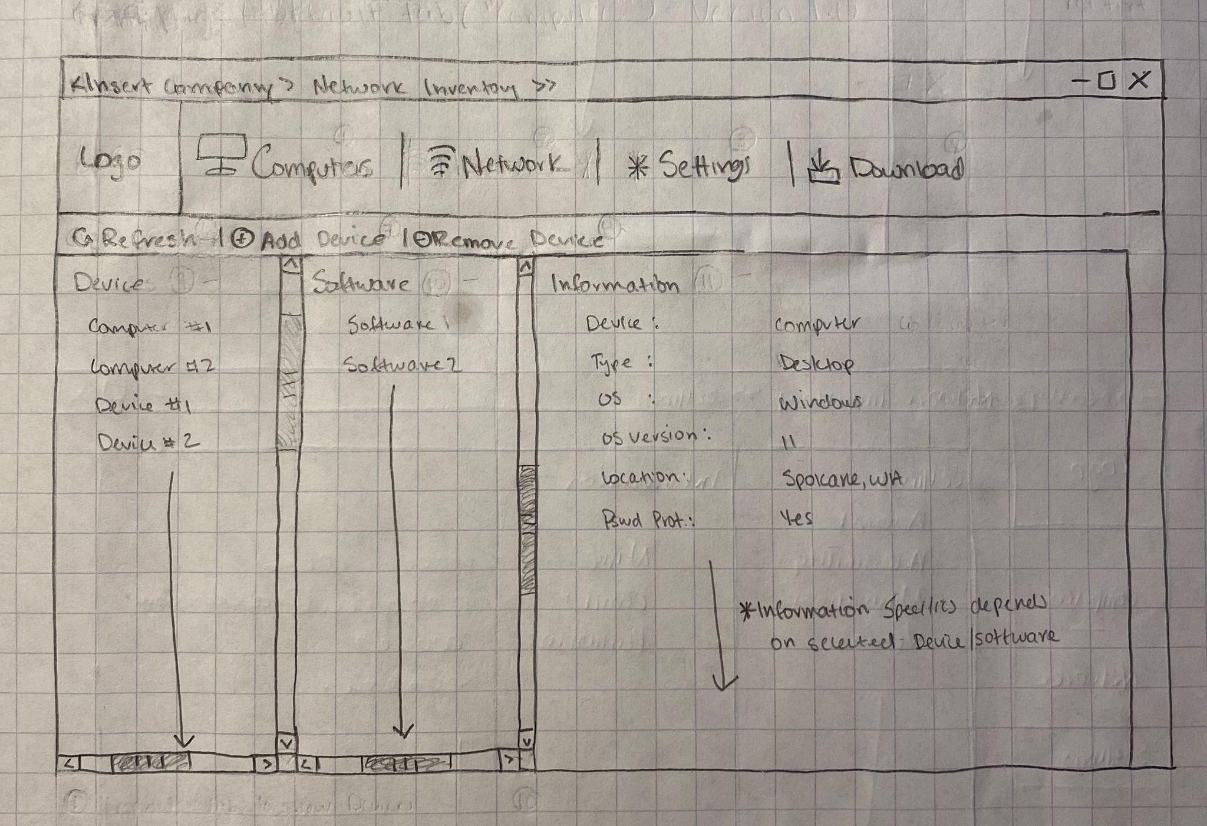

Version 1 of the main

homepage which will appear

after the user correctly enters

their username and password

in the login window. This

homepage is the same as the

“computers” tab in the

sketch.

Homepage Version 2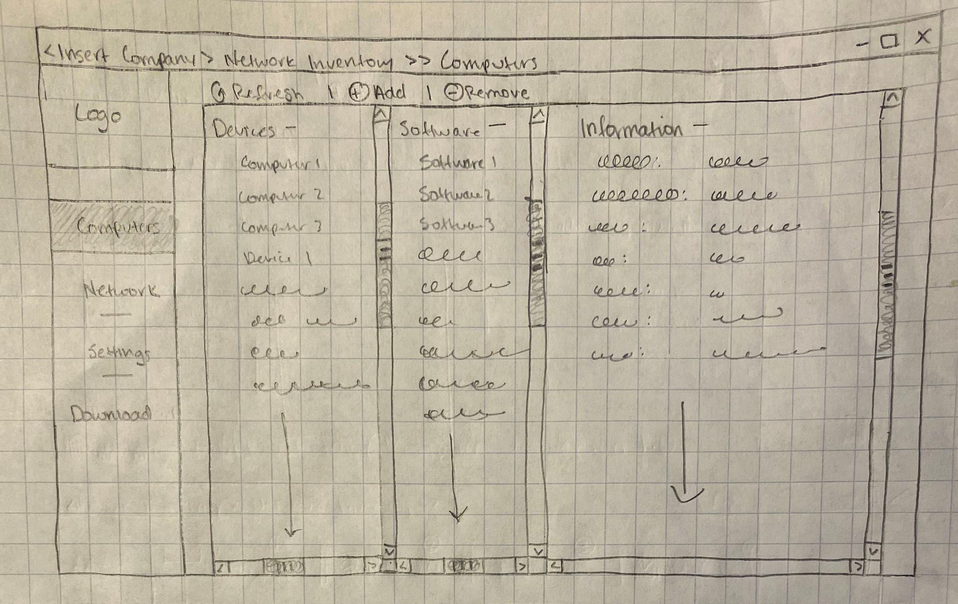

Version 2 of the main

homepage which will appear

after the user correctly enters

their username and password

in the login window. This

homepage is the same as the

“computers” tab in the

sketch.

Settings Version 1

The settings versions 1 tab

will show account Information,

accessibility options, the

software version and other

miscellaneous settings.

Settings Version 2

The settings versions 2 tab

will show account Information,

accessibility options, the

software version and other

miscellaneous settings.

Network Version 1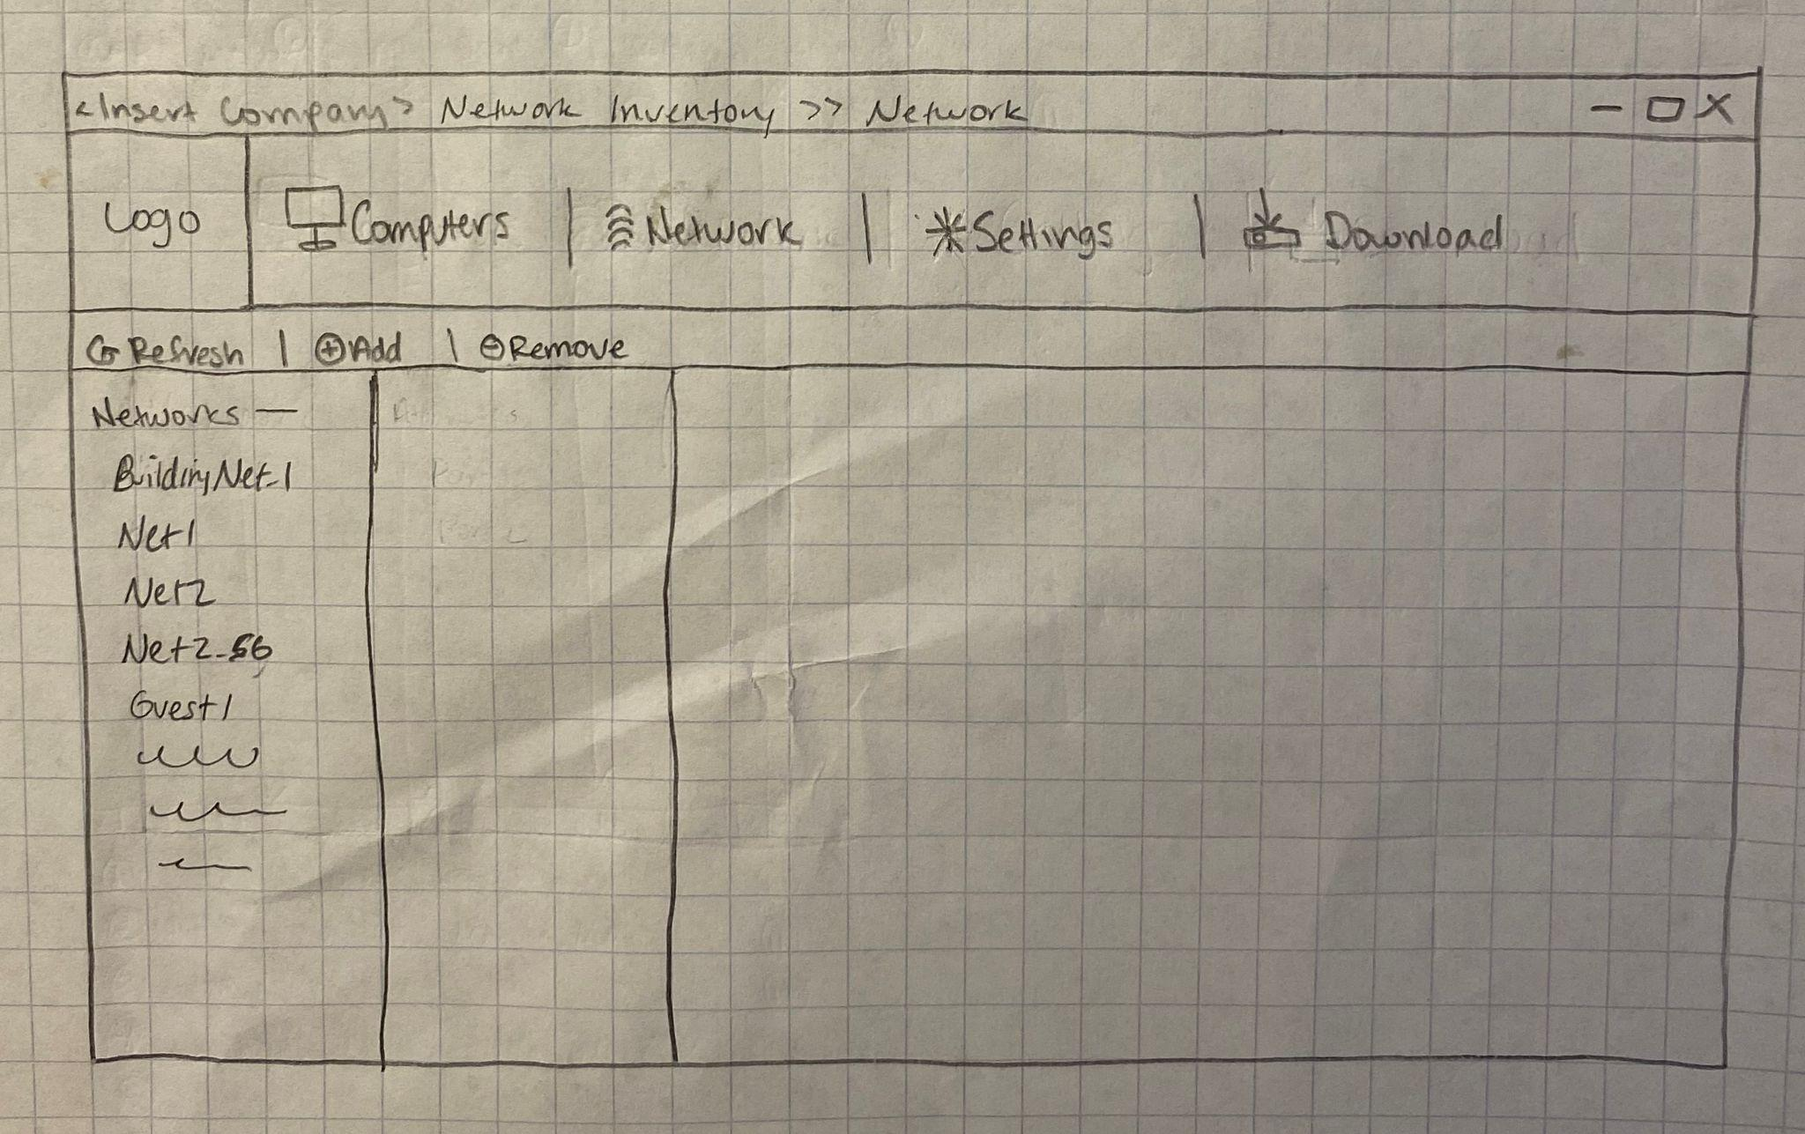

The network version 1 tab

Will show the setwork

Configurations and other

Information regarding the

Network and network

Technologies themselves

**3.2 Initial Software Architecture**

Our system consists of two main components: the network crawler agent and the database. The crawler agent will be launched from the terminal. As it crawls the network and finds target devices and software, it will insert them into the database, updating it. When the network crawl is complete, the database will be exported to an Excel spreadsheet, following the format of the example spreadsheet.

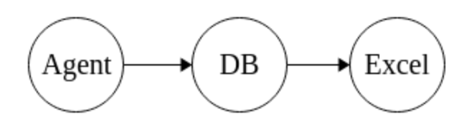

**3.3 Development Environment, Tools, Languages, and Libraries**

List off the various categories of required development tools and dependencies the project design is expected to have. What languages will the various components be done in? What libraries or frameworks do you expect to need? What IDEs, testing harnesses, or other parts will be needed. Are you relying on any Internet APIs for data, cloud platforms, or computing engines? List off the expected components of your initial design.

We expect our major features to require development tools and dependencies. Beginning with the retrieval of data, the crawler agent will utilize the terminal to launch its search for networks and devices connected to it; this requires a well-built network scanner for detecting devices which can be used from an existing program such as SoftPerfect Network Scanner. This software scans TCP ports for internal and external IP addresses, and provides an exportable CSV (among other) formatted reports which is ideal for our Sponsor. The tool uses nmap and ssh commands, provides data on operating system discovery, and conducts vulnerability tests (<https://www.softperfect.com/products/networkscanner/>). This specific software will cover most of the crawler-needed elements of Software System/Medical Devices, but the crawler agent will also need to scrape information about server location and if it is located in the Cloud or on the premise, and ePHI with or without encryption. Once the crawler gets this information, it will be stored into the database.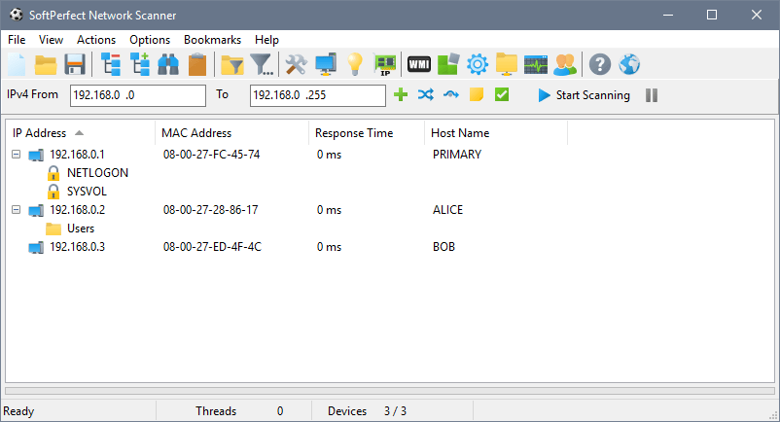

Our database will use either MariaDB or SQLite based on Sponsor’s capacity needs and which will be easiest to implement into the company's existing software/systems. The DB must store server information and device information noted above in addition to user authentication methods and credentials to login securely. *The DB will also hold information about Location: department/space location/date of last order, Purchase: vendor, purchase price per item/warranty expiry date, and Quantity/Value: condition, quality, asset value/total value, and Asset Information: model, vendor NO./remarks/photo or link. These attributes will likely be provided without having to use the crawler agent.* Database IDE could be dbForge which is compatible with a non-local stored MariaDB or MySQL DB. To validate credentials, the DB will use either a query that matches login information or it utilizes libraries like <https://mariadb.com/resources/blog/how-to-connect-python-programs-to-mariadb/>.

If UI is necessary, it will likely use HTML/CSS to create the interface and connections to DB and agent.

**3.4 Initial Software Test Plan**

Provide a description of your plans for testing your software product for quality assurance and overall usefulness for your target user groups. Your plan must include details concerning the tests you plan to do, the significance and purpose of the tests, and when during your project you plan to perform them. Note that you must leave enough time to address issues that arise from testing. Be sure to include and explain any additional types of tests that are meaningful or necessary for your project, such as testing performance, security, deployment, and so on.

Our software test plan will have to validate our user interface (UI), our output file, our network crawler agent, our database, security, and all business requirements. For our UI, we will test if the login menu functions correctly and that users will only be able to access the software if they successfully put in their credentials. For the output file we will need to test that the data is displayed properly (in correct columns, no missing data, etc) in the Excel spreadsheet. For the network crawler agent we will need to test if the crawler agent grabs all the target devices in a given network. The most important part of the software that must be tested in the database, since it has the majority of the important data we want to output. We must ensure that all data in the database is valid (correct data types) and are under the correct columns. We must verify that the database is properly storing all the devices and software into the database, ensuring that they are all accounted for. The naming conventions for the columns must make sense to the user. The primary and foreign keys must also be valid in order for the querying to work correctly. Just as important for our project are tests that address performance, security, and deployment are working for our project. The software must be secured and that only verified users have access to it. While we are unsure of the magnitude of data we are handling, the software should be able to perform at a reasonable level. We must also ensure that the software that we develop ends up working as expected and is natural to the users.